Functional Specification

Year: 2025 Semester: Spring Team: 10
Project: Smart Card Shuffler
Creation Date: January 24, 2025 | Last Modified: January 23, 2025
Member 1: Krish Kumar | Email: kumar585@purdue.edu
Member 2: Craig Eagleburger | Email: ceaglebu@purdue.edu
Member 3: Brendan McLaughlin | Email: btmclaug@purdue.edu
Member 4: Johnny Hazboun | Email: jhazboun@purdue.edu

Assignment Evaluation: See Rubric on Brightspace Assignment

1.0 Functional Description

The Smart Card Shuffler is designed to reorder a standard deck of cards into the order of a user’s choosing. The user will select an order, a desired hand, or a random shuffle via a phone app, and the smart card shuffler will recognize the cards with a camera, then place the cards of the deck into that order. All forms of standard playing cards will be accepted, and additional software will enable the user to select specific card games and settings to generate deck pseudo-random layouts for a particular game outcome. For example, a user could select a hand they want to win with in a poker game of five players, and the system will then create a pseudo-random deck that contains the selected hand in a position to be dealt to the user.

See Appendix 1 for Functional Block Diagram

2.0 Theory of Operation

One main component of our Smart Card Shuffler is the system to actually sort the cards. To perform this, the team will use a large wheel with 52 total slots, one for each card in the deck. As discussed later, it has not yet been determined whether or not we will sort when inserting into the wheel or when removing from the wheel, but it does not change the basic operation of the system. The team plans to use a large high-precision stepper motor in order to ensure that the proper angle is achieved to select the correct slot to insert/remove the card. While high-quality motors are capable of this, the team would like the ability to increase the overall speed of the sorting process, which will result in higher quantities of torque and more difficulty achieving accuracy. As such, the team plans to implement a PID control system to vector the speed and torque of the motor to increase the accuracy and minimize error, as without a control system it is likely that the motor will enter a system where it overshoots the mark and then overcorrects due to an inability to instantly stop the angular momentum of the drive and the attached wheel.
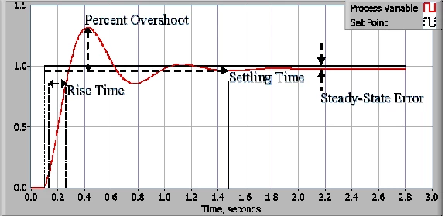
An example of a system without PID. It shows how the system overshoots and overcorrects until settling properly. [2]
PID stands for Proportional-Integral-Derivative control system, where each member represents a separate system for adjusting the power values of the motor. First, each of these parameters is scaled to the current error value, where:
$Error=Set Point - Measured Value$
In this scenario, the set point is the desired angle of the stepper motor and the measured value is the current encoded angle of the motor. This will require that the motor we select will have encoding capability, which will impact the decision of which motor to purchase.
Proportional control is based on the current position and current error level, meaning large errors result in large adjustments:
$P_{output}=K_{p}*Error$
Where $K_{p}$ is an adjustable tuning parameter for proportional gain.
Integral control is based on the accumulated error over time, with the goal of eventually driving the steady state error seen in the graph above to zero. It is calculated by the formula, where $K_{I}$ is a tuning parameter like above:
$I_{output}=K_{I}*\int{}Error dt$
Derivative control is based on the likely future error using the rate of change of the Error value. It is used to prevent sudden changes from rapidly increasing the output at an unsustainable rate. It is calculated by the formula, where $K_{D}$ is a tuning parameter like above:
$D_{output}=K_{D}*\frac{d(Error)}{dt}$
These calculated values are then combined into a final output value, which represents the actual power the motor needs at a given time to reach the desired setpoint efficiently:
$Output=P_{output}+I_{output}+D_{output}$
Each of the individual tuning parameters will need to be adjusted by hand depending on the actual mechanics of our team’s design and the speed at which we want to rotate the card wheel. If implemented properly, the motor should be able to turn the wheel both extremely accurately and at relatively high speeds without jerky motions that could create many points of failure in the design. As such, PID control is a critical portion of the design of the motor driver system.

3.0 Expected Usage Case

The smart card shuffler will be useful in any situation where somebody wants a deck of cards in a particular order. This includes a novelty demonstration of cheating in a card game, designing humorous scenarios in card games, setting up self-working magic tricks where the deck needs to be in a particular order, or organizing the cards a particular way, such as A-K of every suit. It will likely be used indoors in temperatures around 70ºF. The design will be semi-portable, being able to be moved to different tables, but it will not be small enough to fit into a pocket or small bag. Due to its lack of portability, it will not be designed for outdoor use. Users of the shuffler will range greatly, likely aging between 13-70. A proficiency with using playing cards and common mobile phone app layouts can be assumed.

4.0 Design Constraints

4.1 Computational Constraints

Minimum Computation for CV: 700MHz single core CPU, 256Mb memory
Max Required STM32 Constraint: 180 MHz CPU/225 DMIPS, up to 2 Mbytes of dual-bank Flash memory with SDRAM and Chrom-ART Accelerato

Algorithm Constraint: 1 GHz single-core processor and 512 MB of RAM
This is power available for Raspberry Pi Zero

Still need to do analysis on which method would be more time efficient: Presorting vs Postsorting; Algorithm will depend on that

Presorting algorithm: Very low power and CPU usage
Postsorting algorithm: Factor in location of card in shuffler; will use heavy cpu power

4.2 Electronics Constraints

The shuffler’s microcontroller will need to interface with the Raspberry Pi to obtain computer vision information and information received from the mobile app, a stepper motor driver to control the wheel’s motor, DC motor drivers to control the card feeder, and a solenoid or servo motor to control the trapdoor that will allow cards to exit. WiFi and camera interfacing will be handled by the Pi.

The communication with the Pi will happen over UART, which will require two GPIO microcontroller pins that can interface with a UART peripheral.

Common protocols for stepper motor drivers are SPI, I2C, PWM, or a 2-wire parallel interface with lines for step and direction. For all of these except PWM, 2 GPIO ports will be needed. PWM would only require 1 wire. Any of these require a common ground with the motor controller. If I2C is used, pull up resistors are necessary for both signal lines.

The 3 motors (one for moving the card to shooter, 2 for shooting) in the card feeder will all need to be driven by DC motor drivers. Each DC motor driver will require 3 GPIO pins: 2 for direction, and 1 for enable/PWM. Alternatively, the two motors used for shooting out the card could be wired oppositely and be controlled by one motor driver. This would simplify wiring, but limit feedback control for each individual motor.

Finally, the trapdoor will be controlled either by a simple servo or a solenoid. A servo will require one GPIO pin for PWM, and the solenoid will require one normal GPIO pin.

In total, the microcontroller needs 2 UART pins, 1-2 pins for the stepper motor driver protocol, 6-9 GPIO pins for driving the DC motor, and one GPIO pin (possibly connected to a timer for PWM) for the trapdoor.

4.3 Thermal/Power Constraints
The smart card shuffler will be powered by a normal 120V AC outlet, which will be converted to several different values of DC voltage for internal components using a PC power supply. The required voltages are 15V, 12V, 5V, and 3.3V which are all standard outputs of a PC power supply. To limit power consumption, energy-efficient motors and microcontrollers will be used. The target power consumption is 15W during shuffling and sorting, with a standby mode consuming less than 1W.
Thermal management is essential to make sure the product is safe and also provides reliable operation. The target maximum operating temperature for internal components is 70°C. We will implement some passive cooling methods, such as ventilation slots and heat-dissipating materials to maintain a stable internal temperature during prolonged use. If needed, we could add some fans to help cool down the system. Since the device is not battery-powered, considerations for battery life and charging time are not applicable.

4.4 Mechanical Constraints

- Size and form:
  - The device will have a compact design with approximate dimensions of 10 inches in length, 10 inches in width, and 15 inches in height to fit comfortably on standard tables.
- Weight:
  - The target weight is under 15 pounds to ensure portability without sacrificing stability.
- Durability:
  - The shuffler must withstand regular use without breaking down. The materials selected will resist wear and tear from handling and operation of the wheel mechanism. The design will also involve some high tolerance and low friction materials to ensure no cards get stuck.
- Environmental Considerations:
  - The device will operate indoors and will not face harsh conditions other than minor shocks and vibrations. The shuffler is not required to be weatherproof, however it should still be properly sealed to resist dust and protect internal components.
- Mechanical Packaging:
  - The wheel mechanism must securely hold each card without damaging them by bending. Slots will be designed to fit standard playing cards. The ejection system will precisely and reliably release cards ensuring no misalignment. The shuffler involves a lot of moving parts such as the wheel, small ejector wheels, and cards. These parts need to be enclosed to prevent user injury. Additionally, the shuffler must have non-slip rubber feet to ensure stable operation.

4.5 Economic Constraints

Project Cost Constraints: $400
Finish by: Spark Challenge (Last Week of April)
Estimated Cost of Components:

Item | Expected Price
Mechanical Components
Gears | 20
Packaging | 30
Wheel | 0 (ECE machinist says he has scrap for us to use)
Electrical Components
Cameras | 60
PCB | 100
Motor | 0 (from ECE Shop)
Motor Controller | 0 (from ECE Shop)
Microcontroller | 150
Communication Chip | 15
Misc. | 25
Total | 400

4.6 Other Constraints

5.0 Sources Cited:

[1]“Laptop: Minimum System Requirement for OpenCV - OpenCV Q&A Forum,” Opencv.org, 2017. https://answers.opencv.org/question/179923/laptop-minimum-system-requirement-for-opencv/ (accessed Jan. 26, 2025).
[2] “The PID Controller & Theory Explained.” ni.com. Accessed 1/25/2025. [Online] Available: https://www.ni.com/en/shop/labview/pid-theory-explained.html#:~:text=As%20the%20name%20suggests%2C%20PID,are%20discussed%20in%20this%20paper.

Appendix 1: Functional Block Diagram

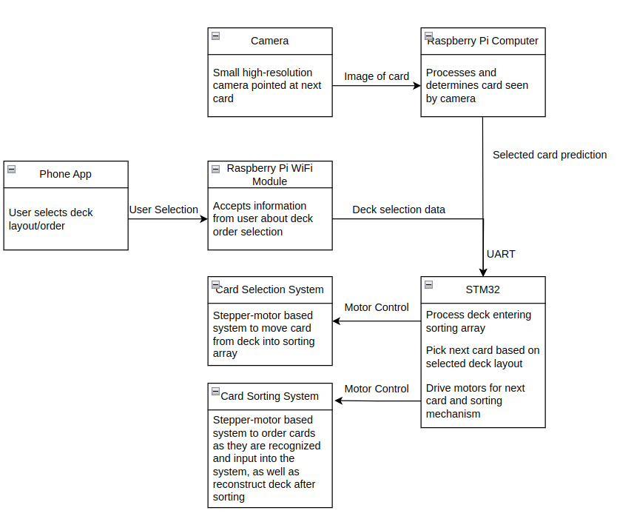
Appendix Figure 1: Functional Block Diagram of Pieces of Smart Card Shuffler

